# INTRODUCTION

* The closet to “**INDIVIDUALS AND INTERACTIONS over processes &** **tools”** is an initiative taking process as our project indulges with the user and interact with the relative as the user finds any threats around her. It takes an initiative for valuing people more highly because they respond to the needs of the user. Communication & interactions between the individuals justifies a proper requirement when a need arises.
* People are adapted of using mobile phones everywhere that traits a **“WORKING SOFTWARE over comprehensive documentation”** that is diversified for a social cause or

mis-happening with anyone around. The efficient way to minimize the chances of becoming a victim of violent crime is to identify and resource yourself from the security app in order to get out of dangerous situations.

* **“CUSTOMER COLLABORATION over contract negotiation”** clarifies the user as the client collaborates throughout in the making of the development process. Waterfall model stimulates the requirement for the product, prior to negotiation. Our app accommodates with scrum development. It is trust worthy and motivates the people around for a consistent support pace.
* **“RESPONDING TO CHANGE over a following plan”** with the intention of developing plans that illustrates the approach of an individual’s capability that determines change as an expense. Our app is a positive change that will help the user in every manner by an alignment through people’s signatories. The positive changes provide an additional value that uncovers its impact on negotiation.

These 4 manifesto are meant to guide and inspire us to build secure software in an efficient way. The agile approach to software development is defined by the commitment of creating software incrementally. The approach offers new versions or releases of the software that follow brief periods of work. It may involve the collaborative work of multiple self-organizing teams composed of members who have different functional expertise but are working for the achievement of a common goal. The manifesto also wants to prioritize the creation of working software, not the generation of documentation, collaboration with the client instead of spending more time on contact negotiation.

# DATA FLOW DIAGRAM

## DFD LEVEL - o

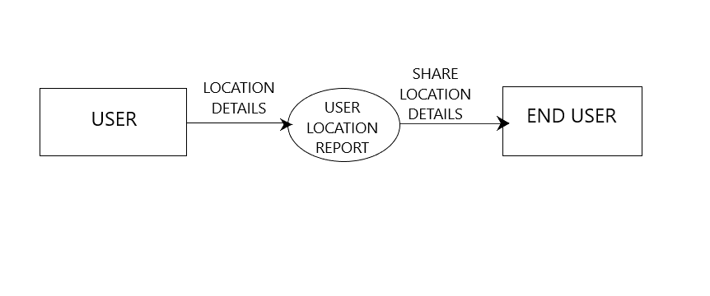

## DFD LEVEL - 1

